**Supplements for P**r**ogression of white matter** hyperintensities is related to blood pressure increases and global cognitive decline – a registered report

Frauke Beyer1,2

Laurenz Lammer2

Markus Loeffler4,5

Steffi Riedel-Heller5,6

Stéphanie Debette1

Arno Villringer2,7

A. Veronica Witte2,3,7

1 Bordeaux Population Health Research Center, University of Bordeaux, Inserm, UMR 1219, Bordeaux, France   
2 Department of Neurology, Max Planck Institute for Human Cognitive and Brain Sciences, Leipzig   
3 CRC 1052 “Obesity Mechanisms”, Subproject A1, University of Leipzig   
4 Institute for Medical Informatics, Statistics and Epidemiology; University of Leipzig   
5 Leipzig Research Centre for Civilisation Diseases (LIFE), Leipzig   
6 Institute of Social Medicine, Occupational Health and Public Health, University of Leipzig , Leipzig   
7 Day Clinic for Cognitive Neurology, University Hospital Leipzig, University of Leipzig

# Missing data pattern

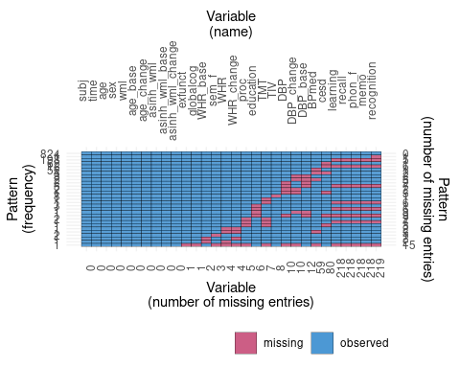

# Comparison to a change score model

We compared our results from the mixed effect model with the approach taken in Debette et al. (2011) using change in raw WMH volume or asinh-transformed WMH volume as outcome measure in a linear model (see Table 1). In the change score model with raw WMH volume as outcome, higher DBP at baseline was associated with WMH progression, this was attenuated when using asinh-transformed WMH as outcome. Comparing the model assumptions of the original model (Figure 1 with the change score models for raw and asinh-transformed WMH (Figures 2 and 3), we noticed that the assumptions are not well fulfilled for the change score model.

Table 1: Results for DBP baseline and change from linear models using change in raw WMH or asinh-transformed WMH as outcome

|  | Raw WMH: Estimate  [95 % CI] | Raw WMH: p-value | asinh WMH: Estimate  [95 % CI] | asinh WMH: p-value |
| --- | --- | --- | --- | --- |
| Age at baseline | 0.102 [0.081, 0.122] | <0.001 | 0.003 [0.002, 0.003] | <0.001 |
| Time between baseline and followup | -0.080 [-0.361, 0.201] | 0.576 | -0.002 [-0.009, 0.004] | 0.491 |
| DBP at baseline baseline | 0.056 [0.035, 0.076] | <0.001 | 0.001 [0.000, 0.001] | 0.030 |
| Change in DBP | 0.050 [0.030, 0.070] | <0.001 | 0.001 [0.001, 0.002] | <0.001 |

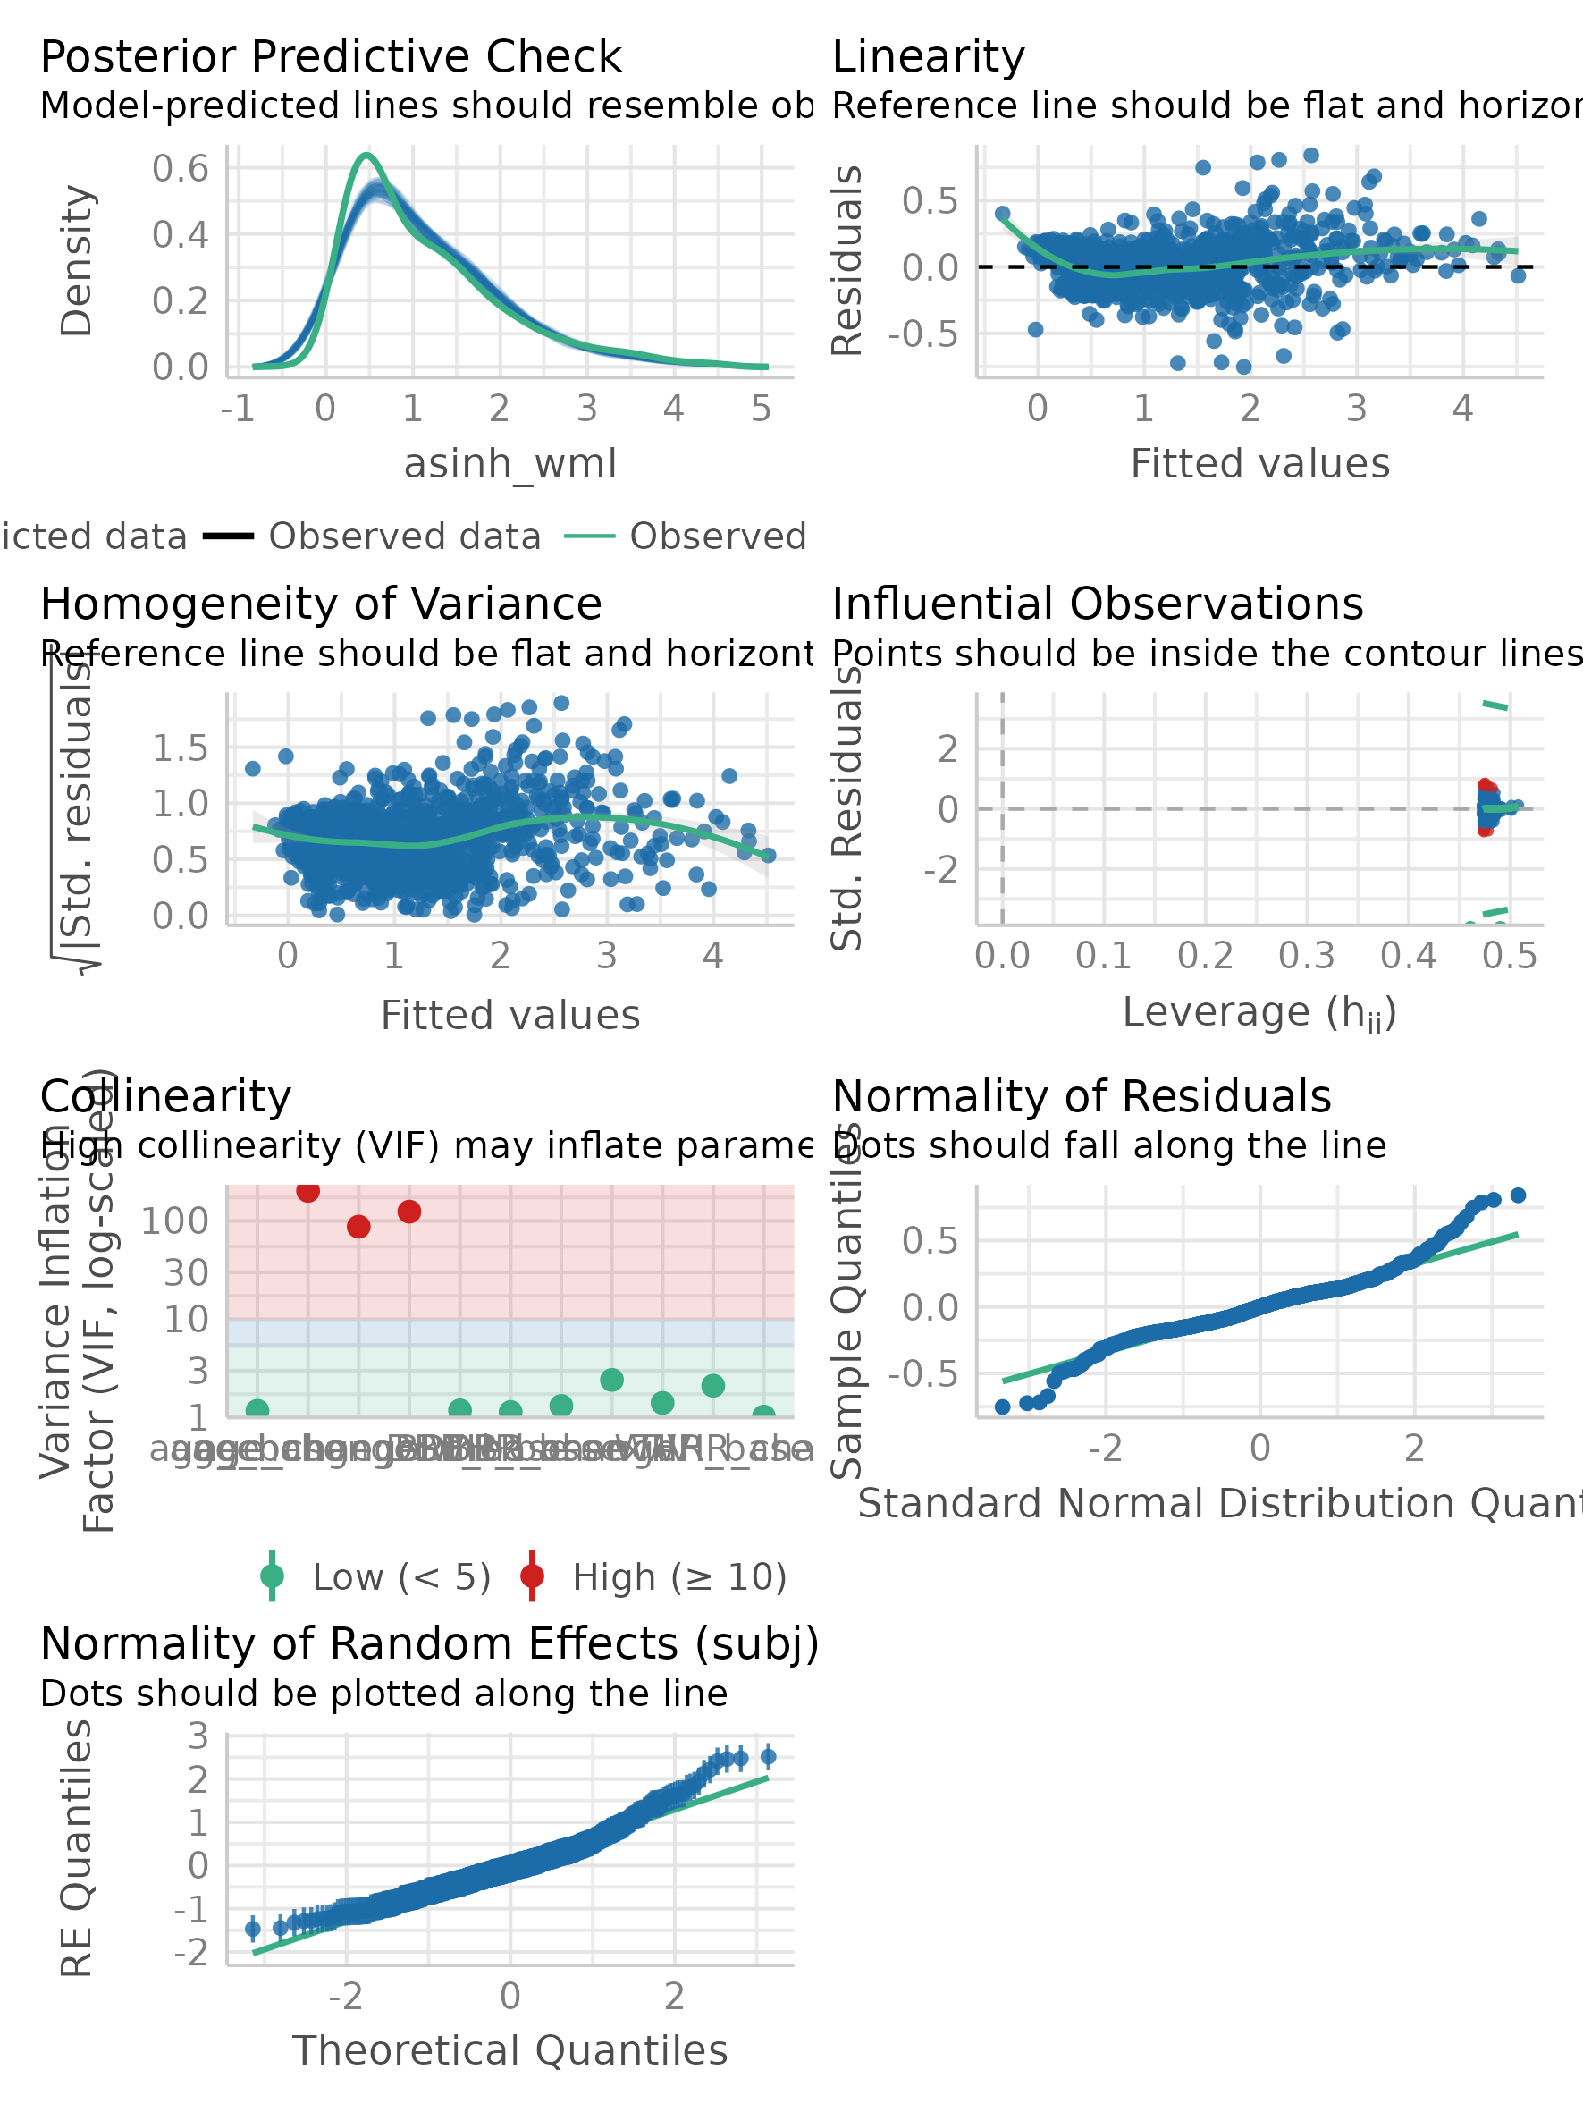

Figure 1: Assumptions of linear model for the original model M1 (from the package check_model)

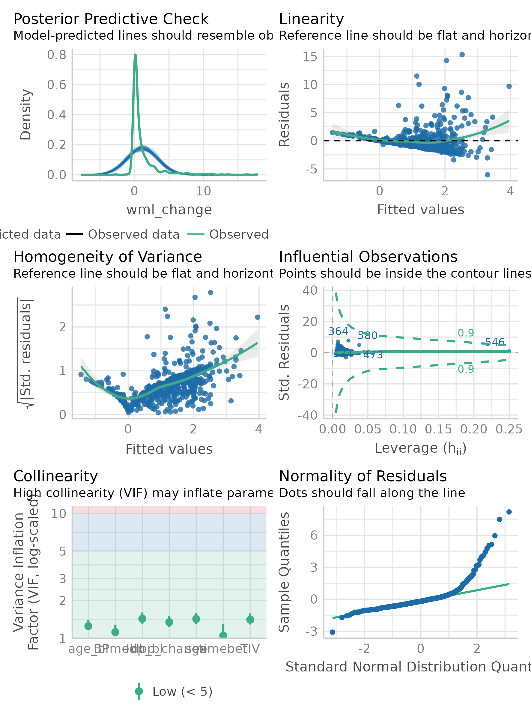

Figure 2: Assumptions of linear model for the change score model using raw WMH volume as outcome (from the package check_model)

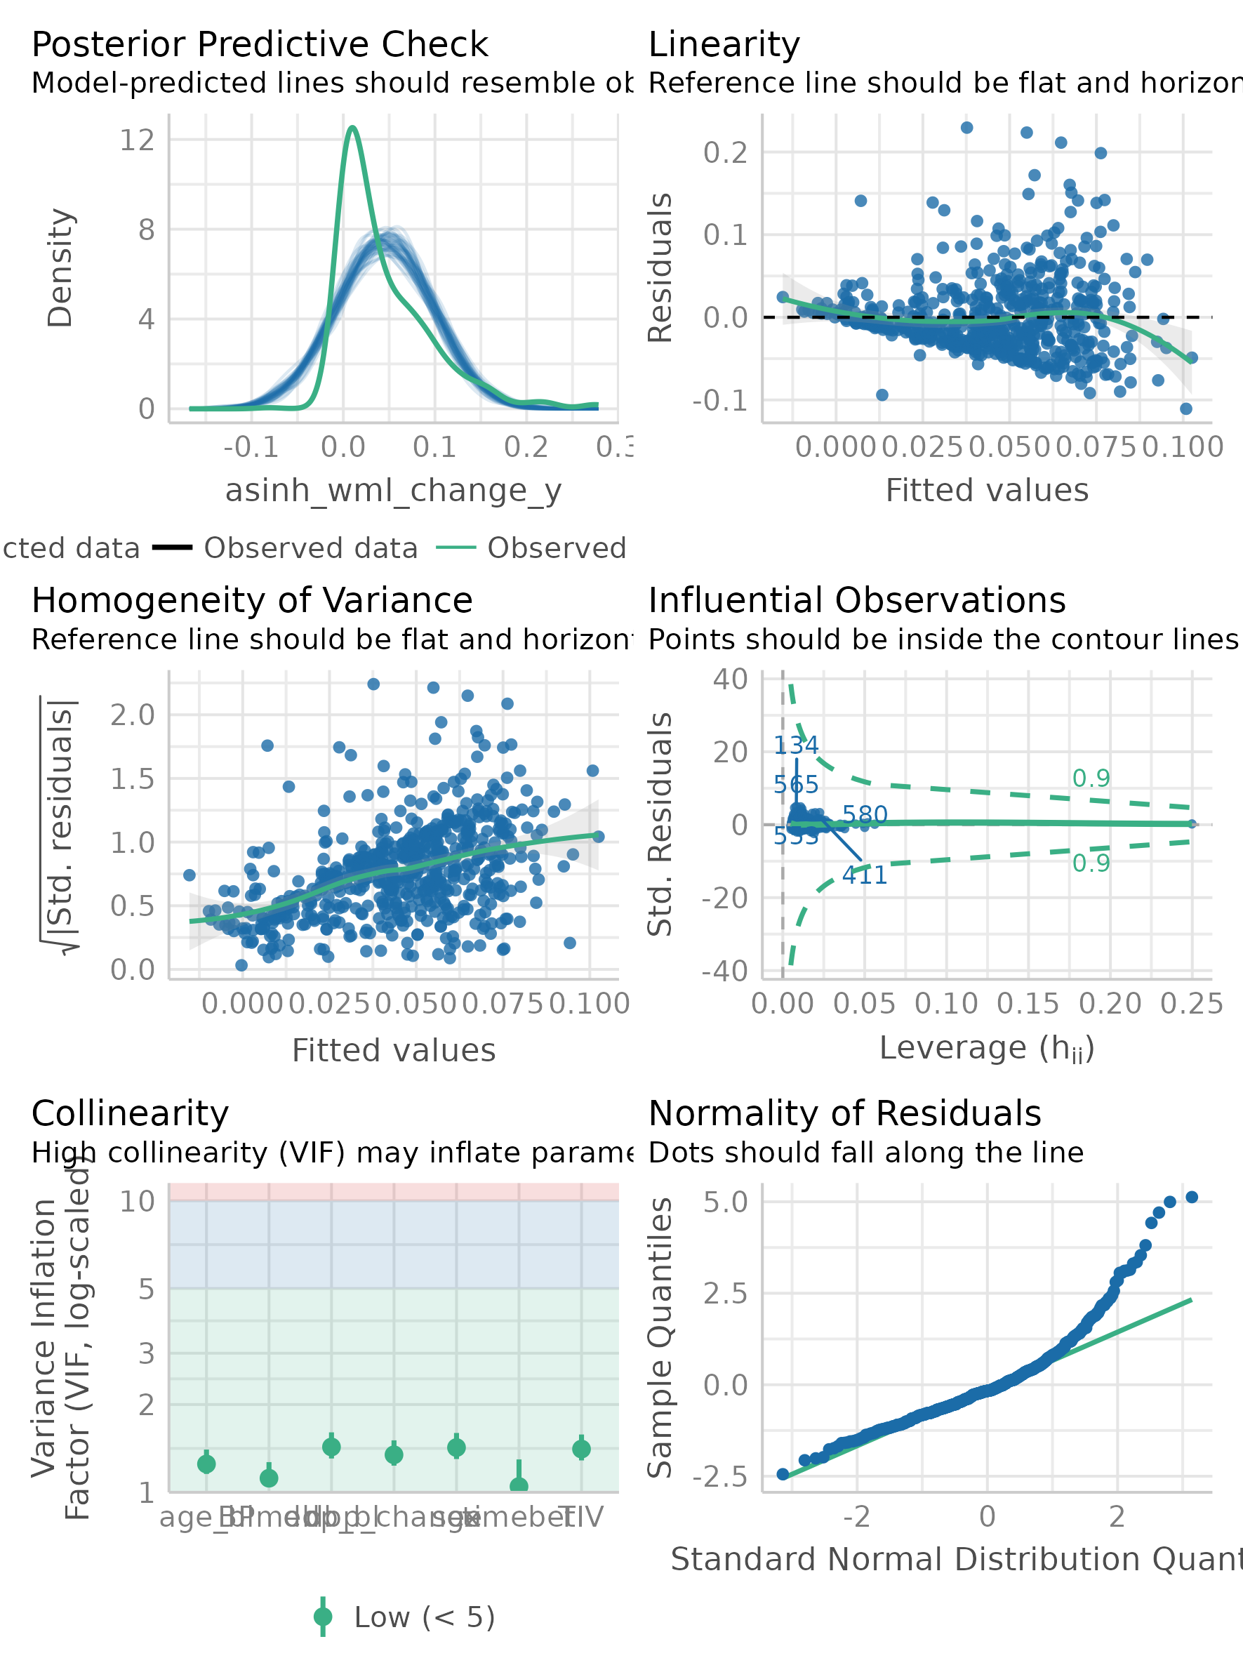

Figure 3: Assumptions of linear model for the change score model using asinh-transformed WMH volume as outcome (from the package check_model)

# Assumptions for models M2 and M3

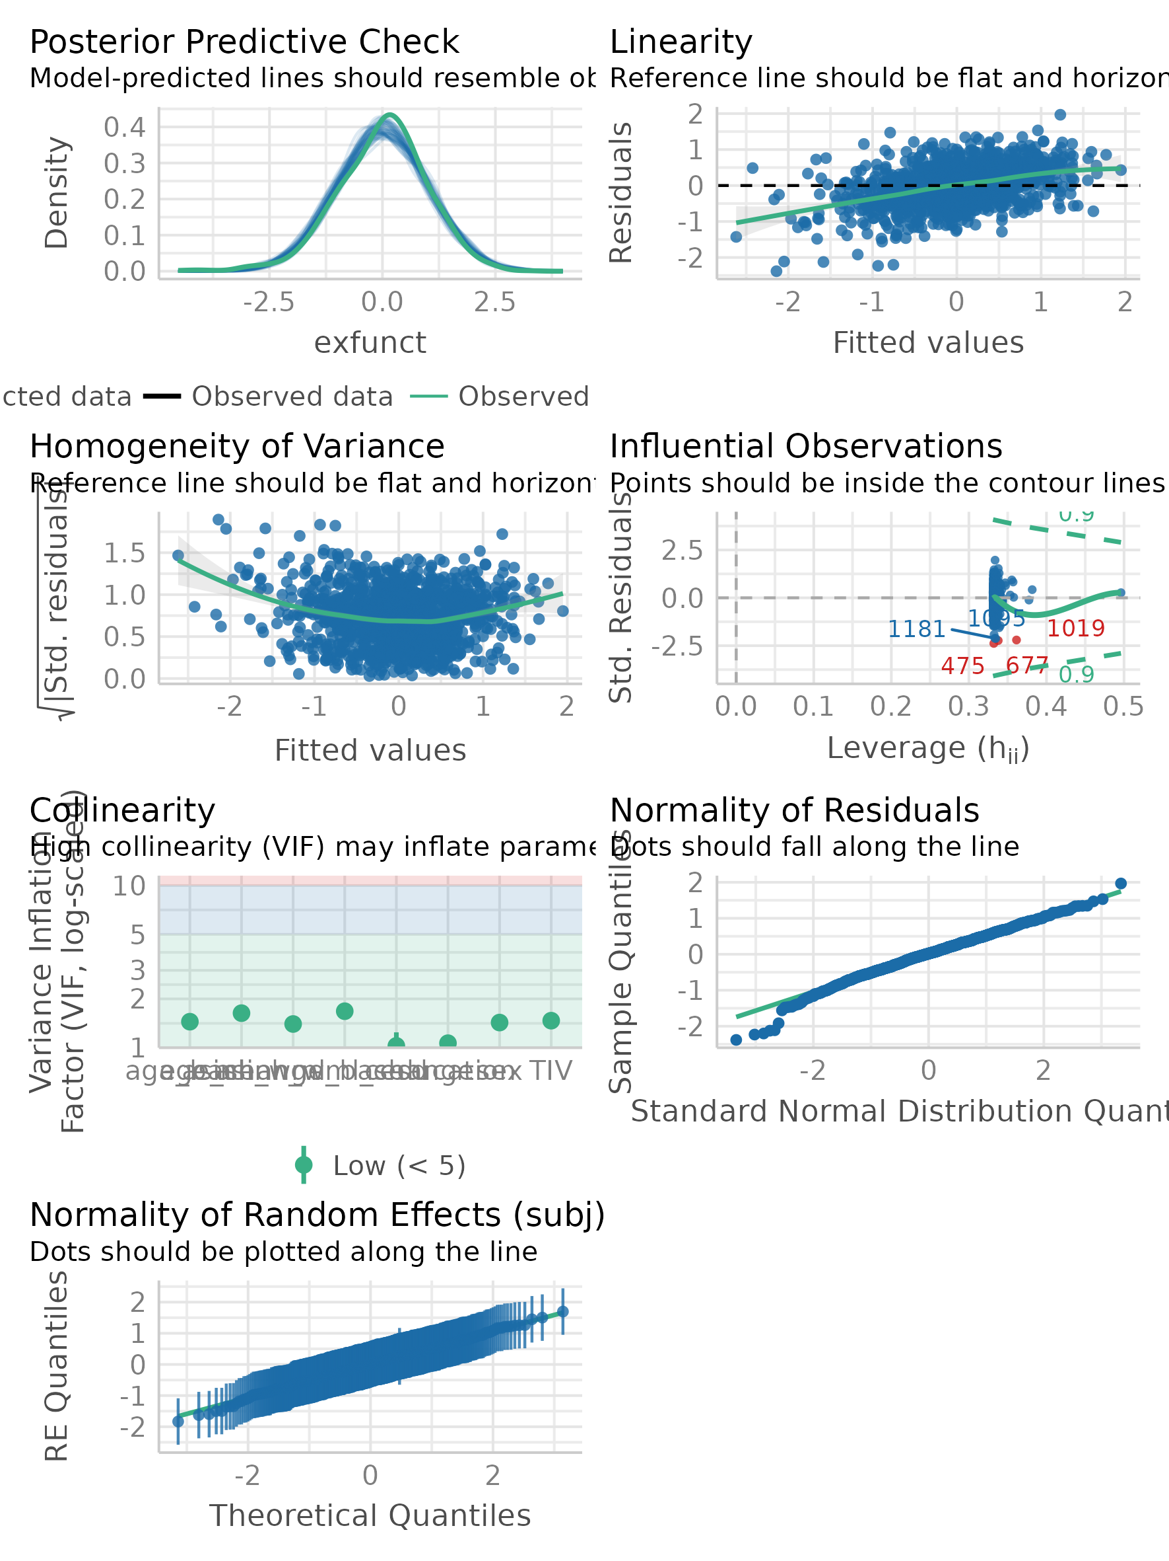

Figure 4: Assumptions of linear model for them model M2 (executive function)(from the package check_model)

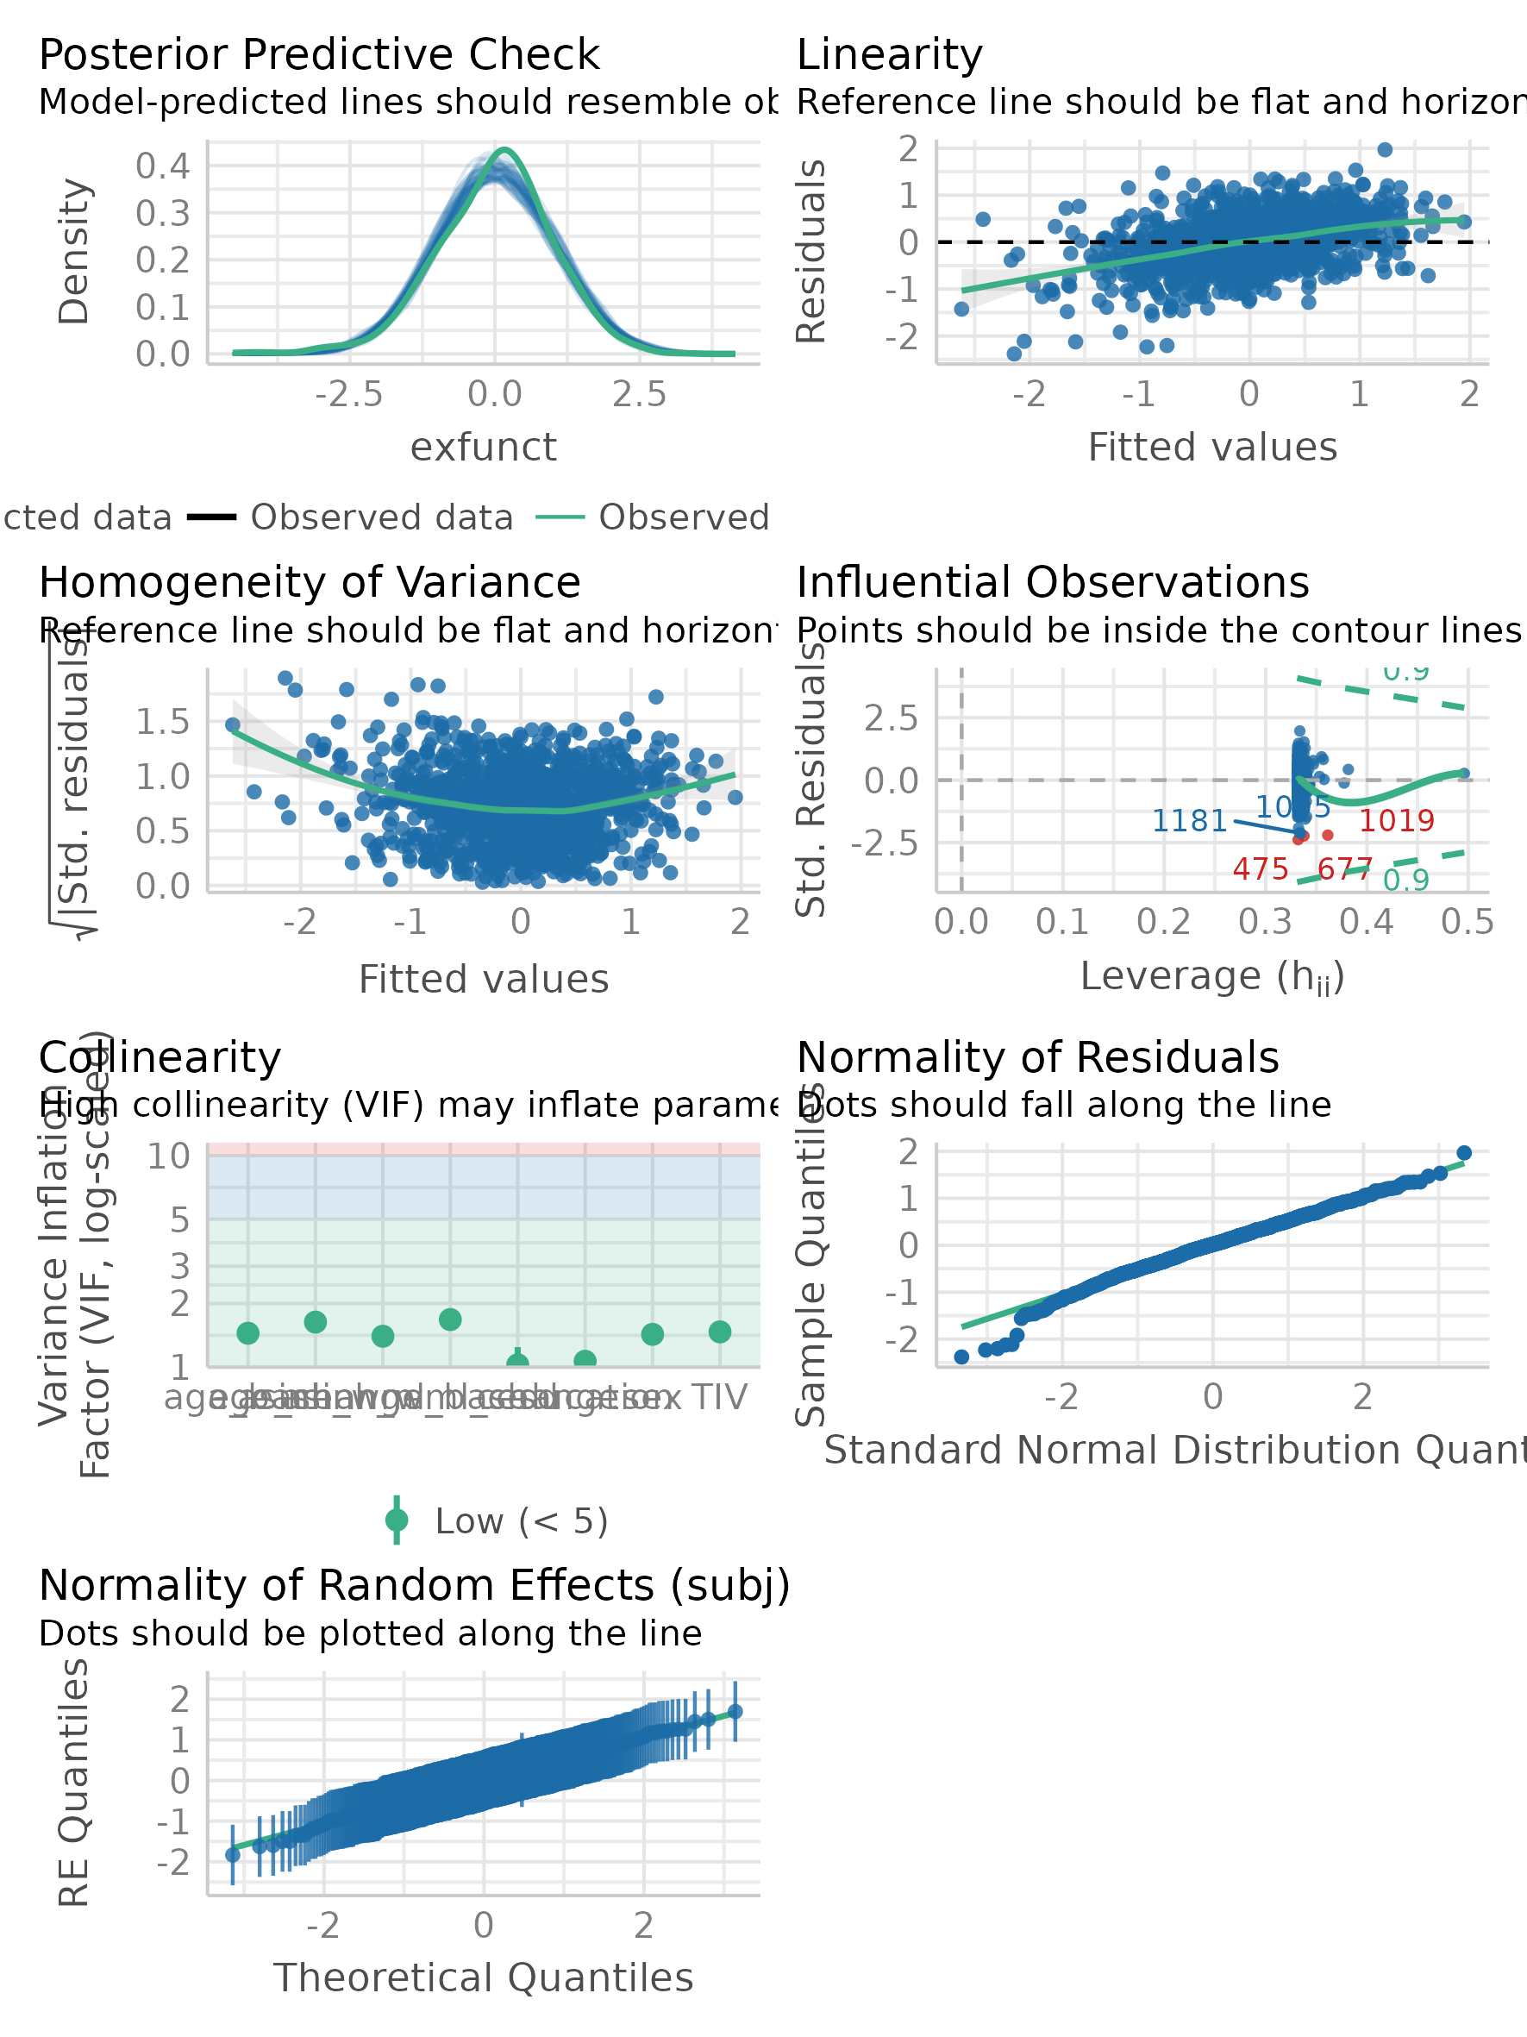

Figure 5: Assumptions of linear model for them model M3 (global cognitive function)(from the package check_model)

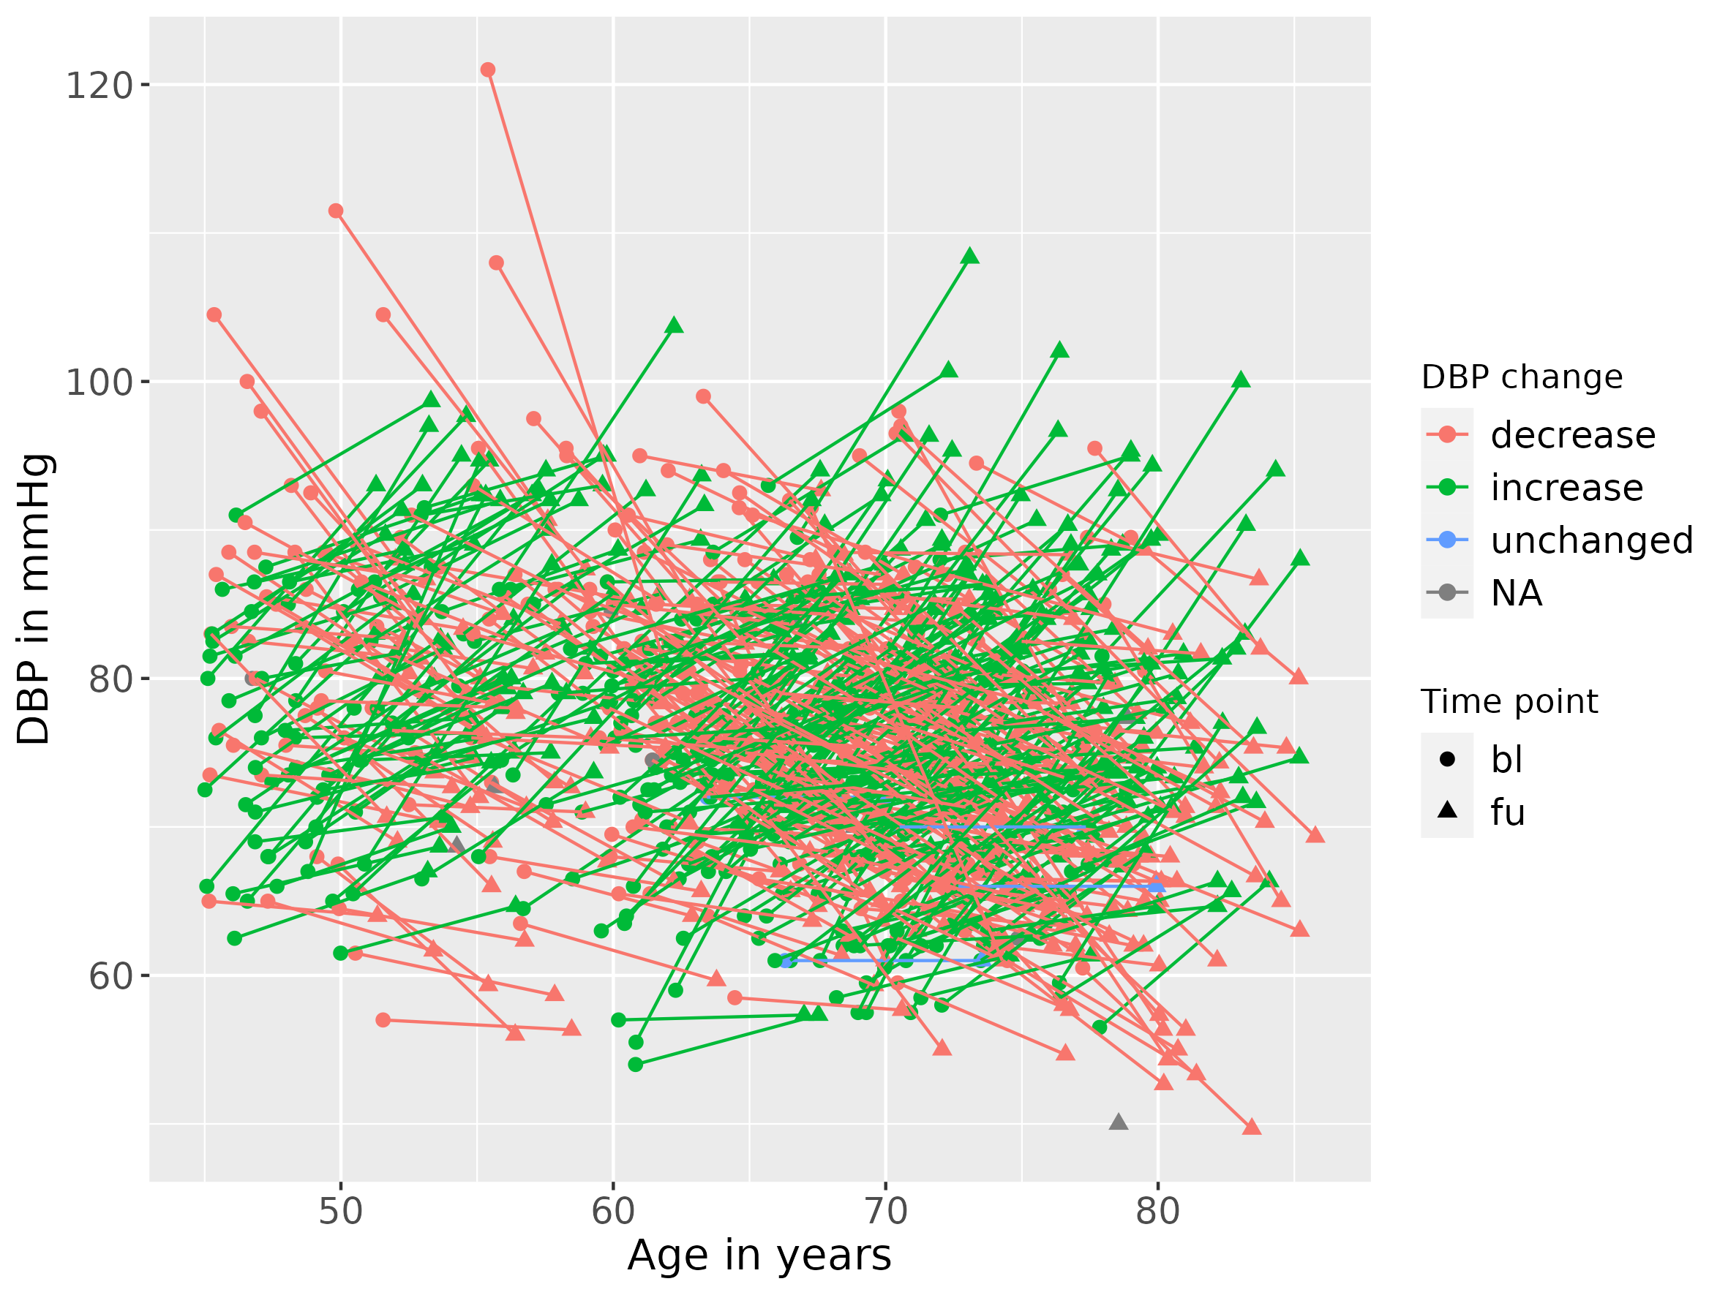

Figure 6: Age and DBP in Life-Adult. Colors indicate increase/stable/decrease in DBP over time.

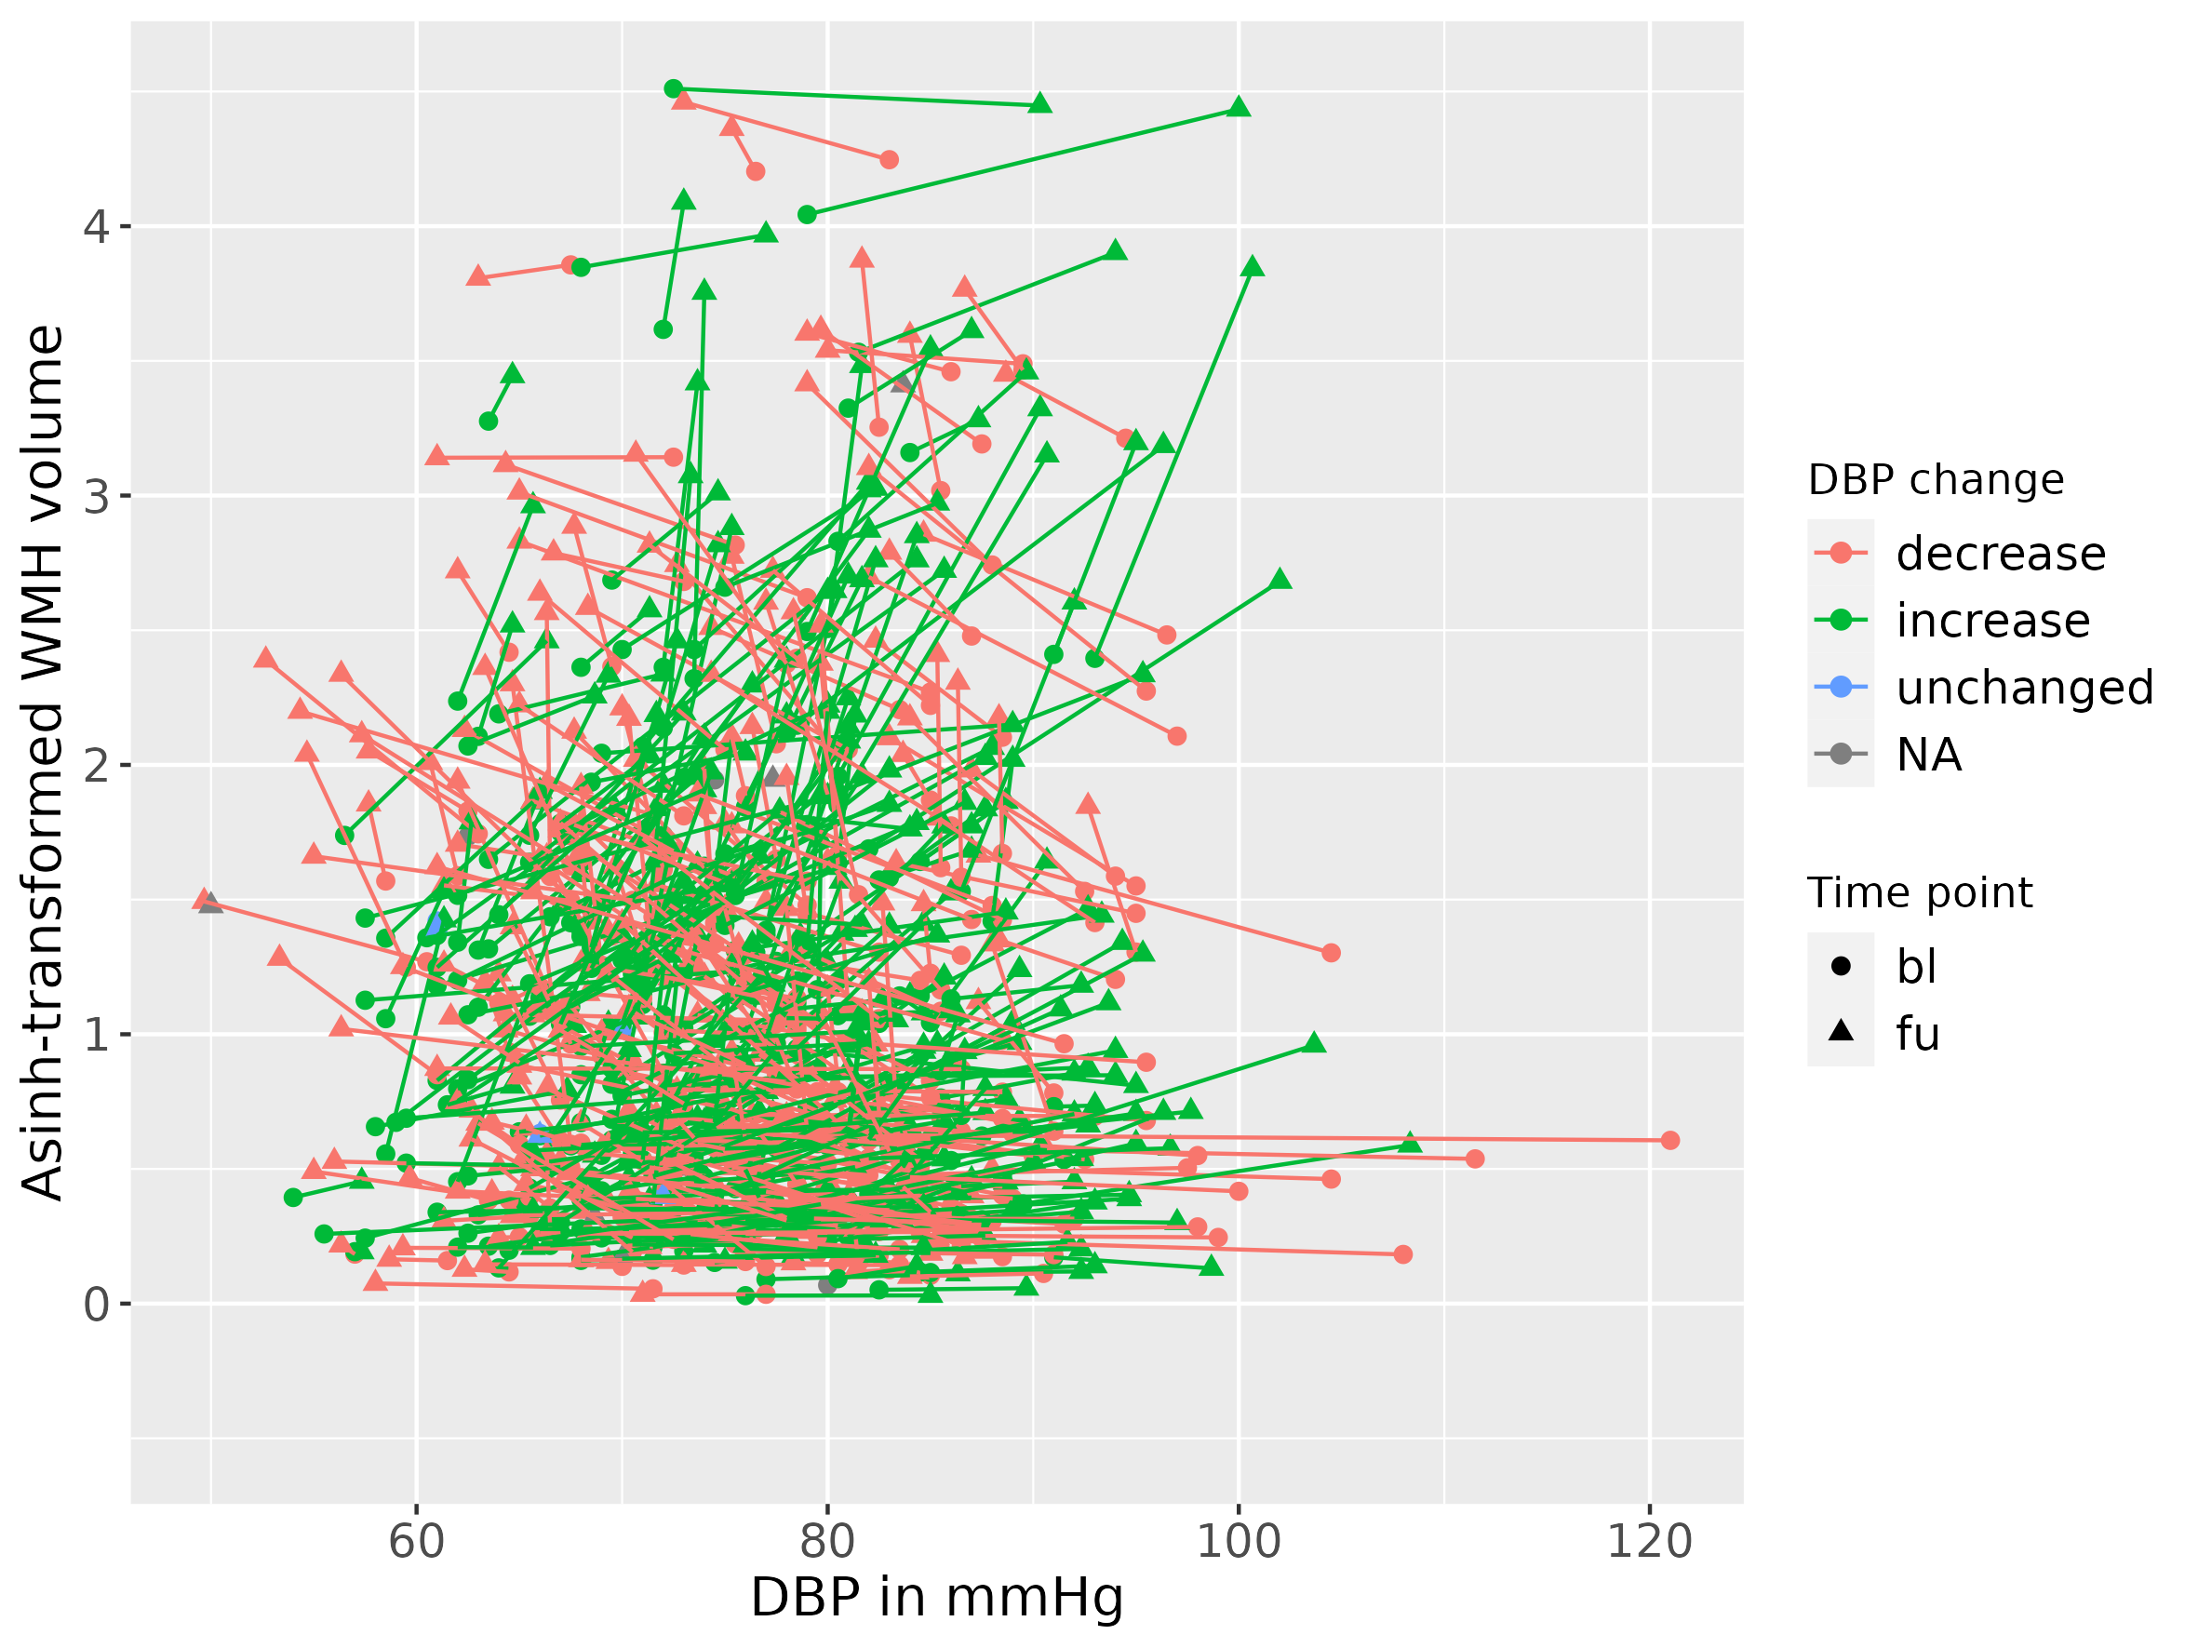

Figure 7: DBP and asinh-transformed WMH in Life-Adult. Colors indicate increase/stable/decrease in DBP over time.

# Interaction Models

Table 2: Interaction of gender and WMH progression

|  | Estimate [95 % CI] | p-value |
| --- | --- | --- |
| Age at baseline | 0.056 [0.049, 0.062] | <0.001 |
| Time between baseline and followup | 0.025 [-0.045, 0.094] | 0.486 |
| Diastolic BP at baseline | 0.012 [0.005, 0.018] | <0.001 |
| Change in diastolic BP | 0.006 [0.003, 0.009] | <0.001 |
| Waist-to-hip ratio at baseline | 0.836 [-0.134, 1.807] | 0.091 |
| Change in WHR | -0.078 [-0.693, 0.536] | 0.803 |
| Gender (males=1) | -0.281 [-0.462, -0.101] | 0.002 |
| Interaction of time and gender | 0.000 [-0.012, 0.011] | 0.936 |
| Interaction of time and DBP at baseline | 0.000 [-0.001, 0.000] | 0.616 |
| Interaction of time and WHR at baseline | 0.031 [-0.035, 0.098] | 0.356 |

#### E2aa: Gender and DBP change interaction (new exploratory analysis)

Table 3: Interaction of DBP change and gender on WMH progression

|  | Estimate [95 % CI] | p-value |
| --- | --- | --- |
| Age at baseline | 0.056 [0.049, 0.062] | <0.001 |
| Time between baseline and followup | 0.026 [-0.030, 0.083] | 0.359 |
| Diastolic BP at baseline | 0.012 [0.005, 0.018] | <0.001 |
| Change in diastolic BP | 0.008 [0.003, 0.013] | 0.002 |
| Waist-to-hip ratio at baseline | 0.843 [-0.116, 1.802] | 0.085 |
| Change in WHR | -0.074 [-0.674, 0.526] | 0.809 |
| Gender (males=1) | -0.282 [-0.459, -0.105] | 0.002 |
| Interaction of DBP change and gender | -0.003 [-0.009, 0.003] | 0.372 |
| Interaction of time and DBP at baseline | 0.000 [-0.001, 0.000] | 0.586 |

#### E2a: Gender and baseline DBP interaction on WML progression

Table 4: Interaction of DBP baseline, age and gender on WML progression

|  | Estimate [95 % CI] | p-value |
| --- | --- | --- |
| Age at baseline | 0.055 [0.049, 0.062] | <0.001 |
| Time between baseline and followup | 0.014 [-0.064, 0.091] | 0.730 |
| Diastolic BP at baseline | 0.015 [0.006, 0.025] | 0.002 |
| Change in diastolic BP | 0.006 [0.003, 0.009] | <0.001 |
| Waist-to-hip ratio at baseline | 0.837 [-0.128, 1.802] | 0.089 |
| Change in WHR | -0.092 [-0.704, 0.520] | 0.767 |
| Gender (males=1) | 0.208 [-0.768, 1.184] | 0.676 |
| Interaction of DBP and gender | -0.006 [-0.019, 0.006] | 0.318 |
| Interaction of time and gender | 0.021 [-0.046, 0.089] | 0.534 |
| Interaction of time and DBP at baseline | 0.000 [-0.001, 0.001] | 0.932 |
| Interaction of time and WHR at baseline | 0.031 [-0.035, 0.097] | 0.361 |
| Gender differences of time x DBP at baseline | 0.000 [-0.001, 0.001] | 0.519 |

#### E2c: Interaction of gender and baseline WHR on WMH progression

Table 5: Interaction of gender and baseline WHR on WMH progression

|  | Estimate [95 % CI] | p-value |
| --- | --- | --- |
| Age at baseline | 0.056 [0.049, 0.062] | <0.001 |
| Time between baseline and followup | 0.052 [-0.045, 0.148] | 0.295 |
| Diastolic BP at baseline | 0.012 [0.005, 0.018] | <0.001 |
| Change in diastolic BP | 0.006 [0.003, 0.009] | <0.001 |
| Waist-to-hip ratio at baseline | 0.705 [-0.745, 2.155] | 0.340 |
| Change in WHR | -0.118 [-0.736, 0.500] | 0.708 |
| Gender (males=1) | -0.493 [-2.254, 1.268] | 0.583 |
| Interaction of WHR and gender | 0.228 [-1.662, 2.119] | 0.813 |
| Interaction of time and gender | -0.049 [-0.171, 0.073] | 0.433 |
| Interaction of time and DBP at baseline | 0.000 [-0.001, 0.000] | 0.618 |
| Interaction of time and WHR at baseline | 0.000 [-0.102, 0.102] | 0.994 |
| Gender differences of time x WHR at baseline | 0.052 [-0.079, 0.184] | 0.436 |

#### E3a: Interaction of gender and WMH progression on executive cognitive function

Table 6: Interaction of WMH progression and gender on executive function

|  | Estimate [95 % CI] | p-value |
| --- | --- | --- |
| Age at baseline | -0.017 [-0.026, -0.008] | <0.001 |
| Time between baseline and followup | -0.047 [-0.061, -0.033] | <0.001 |
| Asinh-transformed WMH volume baseline | -0.017 [-0.116, 0.082] | 0.735 |
| Change in Asinh-transformed WMH volume | -0.097 [-0.370, 0.175] | 0.483 |
| Gender (males=1) | -0.229 [-0.392, -0.066] | 0.006 |
| Interaction of gender and Asinh-transformed WMH change | -0.104 [-0.417, 0.209] | 0.513 |

Table 7: Interaction of gender and WMH progression on general cognitive function

|  | Estimate [95 % CI] | p-value |
| --- | --- | --- |
| Age at baseline | -0.045 [-0.053, -0.037] | <0.001 |
| Time between baseline and followup | -0.040 [-0.052, -0.028] | <0.001 |
| Asinh-transformed WMH volume baseline | -0.044 [-0.135, 0.046] | 0.337 |
| Change in Asinh-transformed WMH volume | -0.231 [-0.463, 0.002] | 0.052 |
| Gender (males=1) | -0.273 [-0.422, -0.125] | <0.001 |
| Interaction of gender and Asinh-transformed WMH change | -0.160 [-0.427, 0.107] | 0.239 |

**Supplementary Table 8**: Constructs & Variables from LIFE-Adult

|  |  |  |  |
| --- | --- | --- | --- |
| Construct | Variable | LIFE-Adults Questionnaire name and field | Timepoint for which measure is available |
| **Variables for exclusion** | | | |
| Conditions to ensure we are looking at a healthy sample | Life-time diagnosis of MS, PD, epilepsy | Medical anamnese (T00173)  MEDANAM_F0171, MEDANAM_F0179,  MEDANAM_F0167 | Baseline |
| Medical anamnese (T01228) MEDIZ_AN_F26  MEDIZ_AN_F27  MEDIZ_AN_F31 (free field, used to screen for epilepsy) | Followup |
| Previous stroke | Medical anamnese (T00173) | Baseline |
| Cardiovascular anamnese (T01226) | Followup |
| Lesion diagnosed by radiologist (ischemic, hemorraghic, traumatic lesions) | Baseline & Followup |
| Incidental findings/non-usability of MRI | Radiologist’s rating (“non usable”)  Radiologist’s rating (incidental finding) | Baseline |
| Radiologist’s rating (“non usable”)  Radiologist’s rating (incidental finding) | Followup |
| Dementia or cognitive impairment | T00043 SIDAM  MMSE < 24 | Baseline |
| T00043 SIDAM  MMSE < 24 or  dementia diagnosis in medical anamnese (T01228)  MEDIZ_AN_F30 | Followup |
|  | Intake of centrally active medication | D00038  ATC codes/groups:  **M03B** MUSCLE RELAXANTS, CENTRALLY ACTING AGENTS  **N02A** OPIOIDS  **N03** ANTIEPILEPTICS  **N04** ANTI-PARKINSON DRUGS  **N05** PSYCHOLEPTICS  **N06A** ANTIDEPRESSANTS  **N06B** PSYCHOSTIMULANTS, AGENTS USED FOR ADHD AND NOOTROPICS  **N06D** ANTI-DEMENTIA DRUGS (except for N06DX02, Ginkgo folium)  **N07A** PARASYMPATHOMIMETICS | Baseline Followup |
| **Used for** | **Covariates** | | |
| All analyses | Baseline Age | Age at first MRI or cognitive assessment | Baseline |
| Age Change | Time between first and second MRI assessment | Baseline  Followup |
| Gender | self-reported binary gender | Baseline |
| eTIV | Estimated total intracranial volume | Summary value of Baseline and Followup |
| Model M1 | Hypertensive medication | Medical (T00173) or medication anamnese (D00038)  Intake of anti-hypertensive medication (ATC code starting with "C02 "C03", "C07", "C08" "C09")  or treatment because of hypertension (MEDANAM_F0039) | Baseline |
| Medication or cardiovascular  Anamnese (T01226)  Intake of anti-hypertensive medication (ATC code starting with "C02 "C03", "C07", "C08" "C09")  or treatment because of hypertension  (KARD_AN_F10_3) | Followup |
| Model M2 | CES-D (log-transformed) | D00041  CES_D_SCORE_SUM  _CES_D | Baseline |
| T00013  CES_D_SCORE_SUM  _CES_D | Followup |
| Education | socioeconomic status (D00140)  Binary variable based on whether participant has tertiary degree (SES2_sesbldg) | Baseline |
|  | **Predictors of interest** | | |
| Blood pressure | Systolic/diastolic blood pressure | T00049  Average of three consecutive measurements | Baseline |
| T01170  Average of three consecutive measurements | Followup |
| Visceral adiposity | Waist-to-hip ratio | D00074 Anthropometry | Baseline |
| T01169 Anthropometry | Followup |
| Cerebral small vessel disease | WML (asinh-transformed)  Voxelwise probability of new WML | From FLAIR imaging | Baseline  Followup |
| Memory function | Cerad learning & delayed recall & recognition | T00044 CERAD-plus test battery | Baseline |
| T00044 CERAD-plus test battery | Followup |
| Executive function | CERAD verbal fluency (S and animals)  TMTB/TMTA | T00044 CERAD-plus test battery  T00042 CERAD Animals  T00041 TMT | Baseline |
| Followup |
| Processing speed | TMTA | T00041 TMT | Baseline |
| T00041 TMT | Followup |

# References

Debette, S., S. Seshadri, A. Beiser, R. Au, J. J. Himali, C. Palumbo, P. A. Wolf, and C. DeCarli. 2011. “Midlife Vascular Risk Factor Exposure Accelerates Structural Brain Aging and Cognitive Decline.” *Neurology* 77 (5): 461–68. <https://doi.org/10.1212/WNL.0b013e318227b227>.